Royston Rural Watch, June 2019

PC Mark Ellwood 371 & PCSO 6531 Penny Tomsett, PCSO Chris Brabrook 6522

Sgt Jon Vine 1841

Our Non - Emergency Number 101
Join 150,000 residents who are helping to reduce crime in Herts

14 Jun 2019

• Join over 150,000 households in Hertfordshire who have signed up to receive emails about crime in their neighbourhoods across Hertfordshire.

• There’s never been a better time as it’s National neighbourhood Watch Week next week (Monday June 17 to Sunday June 23).

• Simply log on to owl.co.uk and you will receive emails about crime in your local area.

Over 150,000 households in Hertfordshire have signed up to receive emails about crime in their neighbourhoods across Hertfordshire – making it one of the most successful schemes in the country.

During National neighbourhood Watch Week next week (Monday June 17 to Sunday June 23), the Herts Chair Sue Thompson is challenging residents to follow their lead and further increase this number.

She said: “We see time and time again that the villages, towns and cities with the most sign-ups to the Online Watch link, which is part of Neighbourhood Watch, have fewer crimes and there is more community spirit making it harder for criminals to operate.”

Herts Watch is supporting the national More Than You Expect campaign this week, which highlights the diverse work and projects that are delivered locally.

She said: “We are not asking residents to attend meetings or commit to hours of work, it’s simply acting on relevant and local information that is sent out by email. If a burglary has happened in your town, we would let local residents know about it so they take on board relevant crime prevention advice. We also let members know about missing people and details about local community events. Whilst most of the messages are local, we do from time to time let you know about fraud offences and scams but we do limit the messages so as not to bombard residents.”

Police and Crime Commissioner David Lloyd said: “It is fantastic to see so many households in the county signing up to the scheme and I wish to thank all the officers who have worked so hard to make it a success.

“I have always believed in individual responsibility and how all citizens can play their part in preventing crime and protecting the most vulnerable.”

John Hayward-Cripps, CEO Neighbourhood Watch Network, said: “Community development and cohesion activity is absolutely what Neighbourhood Watch is all about. There are lots of examples of where this is the absolute core of what Neighbourhood Watch does. Obviously, crime prevention and reporting has always been at the centre of Neighbourhood Watch and this has been through knowing your neighbour, being neighbourly and connecting people in communities. The strategy is our vision of a society where neighbours come together to create safer, stronger and active communities and to support and enable individuals and communities to be connected, active and safe, which increases well-being and minimises crime.”

Whilst residents are not required to do more than read and act on the messages sent via email, lots of work goes on by volunteers at Herts Watch to help keep our communities safer.

Their work includes:

• Making-up NHW welcome packs for new members, which saves the Constabulary thousands of pounds thus enabling greater support of frontline policing. Herts Watch was awarded a Certificate of Good Work to the two best ‘elves’ and treated to an afternoon tea at Police Headquarters.

• Crimestoppers ambassadors – they will soon be receiving training for this role.

• Attending events to give talks on NHW and Crime Prevention to various groups including Residents’ Associations.

• Attending events for Age UK’s Scam Awareness Month to give talks (they have previously been trained up by the Constabulary and Get Safe Online).

• Attending many events across the county such as community days and dog watch schemes with Safer Neighbourhood Teams to promote NHW and support their safer neighbourhood teams.

• Joining Safer Neighbourhood Team Safer Streets events and organising the Three Rivers Safer Streets events.

• Attending police meetings, crime events, volunteer fairs and OPALS (Older Person Activity, Learning and Safety) events.

• Working with Police Cadets to include them for further developing NHW.

Drivers warned after thefts of catalytic converters

•Drivers warned as thefts of catalytic converters rise.

•Biggest rises have been in the Hertsmere and Watford.

•Toyota Prius model have been particularly targeted.

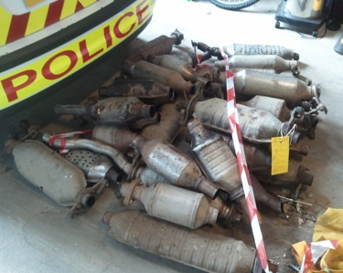

Hertfordshire Constabulary is warning drivers and businesses to be vigilant following an increase in thefts of catalytic converters from vehicles.

There has been a rise in these thefts, throughout the UK, and in Hertfordshire we have seen significant increases, particularly in Hertsmere and Watford.

Catalytic converters, which are fitted to the exhaust system, are targeted by thieves because of the precious metals they contain. Toyota Prius vehicles appear to have been a particular target, with more than half of recorded catalytic converter thefts in the county involving this model.

Inspector Andrew Palfreyman, from Hertfordshire Constabulary’s Crime Reduction Unit said: “Reports indicate that offenders are committing the thefts during the daytime, showing little regard for onlookers. We urge the public to remain vigilant and report incidents of catalytic converter theft, particularly where you see people acting suspiciously, jacking up or working under cars in public car parks or on public roads.”

In order to minimise the chance of becoming a victim of catalytic converter theft we offer the following advice:

•Lock your car in a garage when parked at night.

•When using a garage is not possible, park close to fences, walls or a kerb with the exhaust being closest to the fence, wall or kerb to make theft difficult.

•Consider fitting CCTV to your home or driveway, to help deter thieves.
•Use PIR or LED security lighting to make your vehicle more visible and also as a deterrent.

•If your catalytic converter is bolted on, consider having the bolts welded to make removal difficult.

•Fit protective coverings on catalytic converters, such as the Toyota manufactured CATLOC device, (these are made for Toyota Prius made between 2004 and 2009) as these can make it much more difficult for thieves.

•Have your catalytic converter etched or forensically marked, and put stickers in the windscreen to say this has been done.

•Look for car parks with a Secured Car Park sign which have recognised levels of security.

•Noisy gravel on your drive can help deter a would-be thief, as they don't want to alert you to their approach.

For more crime prevention advice, please visit our website

Alternatively, you can stay anonymous by contacting the independent charity Crimestoppers on 0800 555 111 or via their online form.

Found Dog – Clodagh – Found!!

On 14th June Bedfordshire Police we carried out an unrelated pre-planned operation in a property in Sandy, Bedfordshire. During a search we found a dog in the garden. Our officers recognised her as potentially being the English springer spaniel which had been recently missing from Therfield area.

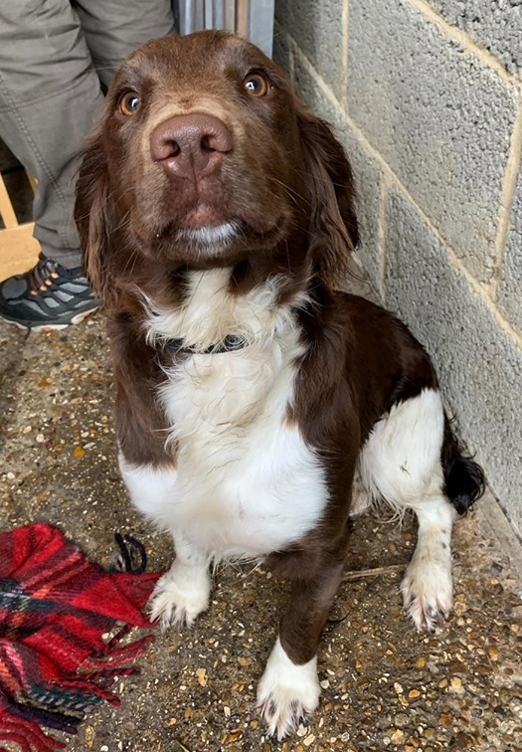
With support from the National Crime Agency Dog Handlers, we took her to the vets who confirmed that she is, in fact, Clodagh, whose family has been desperately campaigning for her return through press and on social media.

Detective Sergeant Kelly Gray, from Eastern Region Special Operations Unit, said:“We are over the moon that we helped to reunite this much loved pet with her family and give this story a happy ending.

“It doesn’t happen often that your dog is returned by a Special Operations Unit and the National Crime Agency. Clodagh’s family now have a quite a story to tell and we wish them all the best in the future.”

Local Crime Information

G4E - Ashwell, Hinxworth, Bygrave, Newnham and Caldecote

41/42155/19 – Newnham Way, Ashwell
Fraud – Elderly victim received a phone call on her landline. From a person that said they were a police officer from the Metropolitan Police. The offender said that two males had been arrested, and upon them they had two cloned cards, which were in the victims name. The victim was then told that these males had taken £400 out of her account. No money was taken from the victim, however it is believed that this would of happened if victim had given over their bank details.

41/45903/19 – Small Gains, Ashwell
Criminal Damage - Between the 21st and 22nd May, an offender has approached a wooden fence at the location, and either jumped on or kicked the fence, causing the top rail to break.

G4D – Barley, Barkway, Reed, Therfield, Kelshall and Nuthampstead

41/41636/19 – Therfield

In the early hours of the 9th May, offenders have climbed over a gate to farmyard. They have attempted to gain entry to a door, a container and a barn, by removing bolts and metalwork. They failed to gain entry.

41/41707/19 – High Street, Barkway

On the 9th of May between 18.15 - 22.45 hours offenders have gained entry to a property, via a rear window, which they smashed, there was an untidy search and some car keys were stolen. At this point they have waited for occupant to return to their home, once they have parked their vehicle and entered property, offenders have then taken the car. Offenders for this crime have been arrested committing another crime in another county.

41/44497/19 – The Pens, Barkway

Overnight on the 17th/18th May, offenders have entered a rear garden of a property. They have approached the shed and cut and removed padlocks. The offenders stole a petrol lawn mower to the value of £1200.

G3C - Sandon, Wallington, Rushden, Clothall and Weston

41/43458/19 – Mill End, Sandon

Overnight between the 8th and 9th of May, offenders have entered a rear garden via fields. They have then entered an unlocked shed and removed hand held gardening tools. This location was further targeted on the 11th to 12th May, damage caused to a locked shed, failed to gain entry.

Your local Neighbourhood Police Teams website

http://snt.herts.police.uk/Teams.aspx?TeamID=G01

Useful Links

http://www.herts.police.uk/

http://www.doglost.co.uk/

http://www.stolenhorseregister.com/

Royston Rural Neighbourhood Team Tel – 01438 757935

