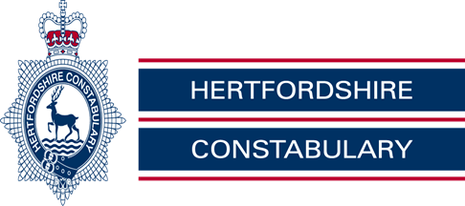

Royston Rural Watch, June 2020

PC Mark Ellwood 371 & PCSO 6531 Penny Tomsett, PCSO Chris Brabrook 6522

Sgt Lee Jessup 560

Our Non - Emergency Number 101
On the Beat –

Dog owners urged to take extra care

• Dog walkers in North Herts asked to take extra care when out and about with their pets

•Increase in reports of people feeling frightened or intimidated by dogs

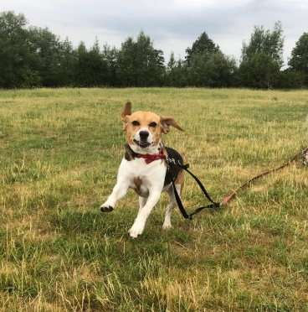
•Dogs seen worrying livestock and other animals

Officers in North Herts are appealing for dog owners to take extra care when walking their pets. This follows an increase in complaints about out-of-control and over-friendly dogs, frightening other walkers and animals.

“Since we have been in lockdown we have understandably seen an increase in the number of people out and about during the day,” explained Neighbourhood Inspector James Lant.
“There have always been plenty of dog walkers around, but now there are far more people out walking with their family, or on bikes, enjoying the countryside during the day. With the easing of lockdown restrictions, this number has increased even further and there are now even more people trying to share the same space.

“With this has come an increase in reports of dogs off the lead, running around and worrying both animals and other people. We want dog owners to be aware of this and make sure, as a courtesy, they put their dog on a lead when near other animals, or when approaching other people.

“You may consider your dog to be very friendly and well behaved, but many people are intimidated by dogs, especially if they are allowed to jump up or pester them. You may have also been walking you dog without issue prior to lock down, but these are now challenging times and our outside space is now much busier than it was. However, with a bit of consideration and thought for others, we should all be able to enjoy the outdoors safely.”

You can tell us what matters most to you about policing, crime or anti-social behaviour in Hertfordshire using echo. Go to bit.ly/police-nherts and have your say

Distraction mobile phone thefts

• Thieves target mobile phones in business premises.

• Distraction techniques are used to steal mobiles left on counters or desks.

• Officers appeal for the public to be on their guard

Police in North Herts are warning the public to be on their guard following a number of distraction mobile phone thefts, which have occurred since more businesses have opened their doors.
Offenders have used distraction techniques, including handing over pieces of paper for staff to look at, or creating a bit of a commotion. Once the offenders have left the premises, staff realise that their mobile phones, which have been out on desks or counters, have also been taken.

“Prior to lockdown, thieves were targeting cafes in a similar way,” said Safer Neighbourhood Team Inspector James Lant. “Offenders often used to put leaflets down on tables, covering any mobiles that were there and then picking up the leaflets and the phone with them. As most cafes are only open for takeaways, thieves are now focussing on other businesses in a similar way.”

So far two estate agents, one in Royston and one in Hitchin, have been targeted in this way, but officers want everyone to be on their guard when they are out and about.

“Never leave your phone out on a counter or desk whilst you are in a shop or café,” continued Inspector Lant. “Make sure you keep it on your person unless you are using it and never in a back pocket or somewhere it is easily accessible.

“We have been liaising with local businesses that are now re-opening, but we want everyone to be on their guard.”

You can tell us what matters most to you about policing, crime or anti-social behaviour in Hertfordshire using echo.

• The team continue to provide a visible presence in local communities.

• We will be working hard to ensure people stay safe and adhere to government guidelines.

• You can report local issues using the echo digital feedback system.

The county’s neighbourhood policing officers continue to engage with local communities as the national emergency progresses.

Safer Neighbourhood Team (SNT) officers will continue to provide a visible presence in your local area, but the way in which we will maintain community engagement has changed. Planned face to face engagement events, such as neighbourhood surgeries, will now be postponed.

Concerns about the causes of crime or anti-social behaviour in your local area can still be shared by using our digital feedback platform, echo

When providing your feedback, please be as specific as possible about issues that matter most to you, echo is anonymous: we will use your feedback, along with our community stakeholders, to set local policing priorities.

Please don’t use echo to report a crime. To do that, contact the Force Communications Room via online web chat or call the non-emergency number 101. If a crime is in progress or someone’s life is in danger, always call 999 immediately.

You can identify your Safer Neighbourhood Team officers, along with information about crime and ASB in your local area, through the Police UK website.

As a direct result of the emergency legislation and the need for social distancing to control the spread of COVID-19 the following public engagement activities will now be prioritised:

• Online community engagement and local policing priorities – echo

• Access to contact information for your local Safer Neighbourhood Team and to see crime and ASB data - police.uk

• Sharing of important community policing messages - Online Watch Link (OWL) and Hertfordshire Constabulary – Facebook / Twitter / website

• A webchat facility is also available via the force website, accessing the Force Control Room (FCR) webchat

You can still contact your local neighbourhood teams using the following methods:

1.By emailing questions or concerns directly to your local SNT by entering your postcode on police.uk

2. By calling 101 and asking to speak to a member of your local neighbourhood team. If they are out on patrol, you can leave a message for them.

3.By using the community voice platform, echo.

4. By online web chat with a Force Communication Room operator at www.herts.police.uk/contact.

You can keep up to date with the government’s latest advice on COVID-19

Local Crime Information

G4E - Ashwell, Hinxworth, Bygrave, Newnham and Caldecote

Non Dwelling Burglary - Between 16/04/20 and 7/5/20 an outbuilding on Ashwell Road Bygrave was burgled. The first time nothing was taken, on the second time plants and gardening equipment were taken.
41/34709/20 and 41/36052/20 refer.

Burglary Other – Between the 21st and 22nd May a farm in Hinxworth was burgled, offenders have taken garden furniture.

G4D – Barley, Barkway, Reed, Therfield, Kelshall and
Nuthampstead

Nothing of Note

G3C - Sandon, Wallington, Rushden, Clothall and Weston

Theft from Motor Vehicle – Between the 8th and 9th of May whilst parked on a driveway in Hitchin Road, Weston an angle grinder was taken from the side door of the vehicle, which was left unlocked due to a fault. The glovebox had also been rifled through but nothing taken. 41/36402/20 refers.

Theft of Motor Vehicle – between the 8th and 9th of May a motor vehicle was stolen that had been parked on Friars Road, Weston. 41/36429/20 refers.

Interference with Motor Vehicle – Between the 8th and 9th of May two cars that were parked on a drive in Hitchin Road, Weston were entered by unknown means, by an unknown offender, who rifled through the glove boxes of both vehicles, but nothing was taken. 41/36614/20 and 41/36851/20 refer.

Theft - Between the 30th and 31st May a yard in Halls Green Weston was broken into, offenders have cut the chain on the gate, gained entry and stolen a crane and trailer. 41/42306/20 refers

Your local Neighbourhood Police Teams website

http://snt.herts.police.uk/Teams.aspx?TeamID=G01

Useful Links

http://www.herts.police.uk/

http://www.doglost.co.uk/

http://www.stolenhorseregister.com/

Royston Rural Neighbourhood Team Tel – 01438 757935

