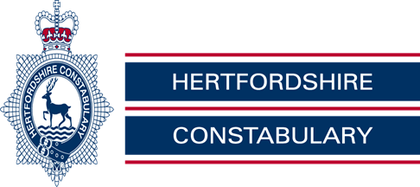

Royston Rural Watch, July 2020

PC Mark Ellwood 371 & PCSO 6531 Penny Tomsett, PCSO Chris Brabrook 6522

Sgt Jon Vine 1841

Our Non - Emergency Number 101
On the Beat –

Look out for signs of large gatherings in your local community

•Police are asking people to be alert to signs of large and unlicensed gatherings.

•Rural areas may be particular targets for illegal raves.

•Police report any information to police.

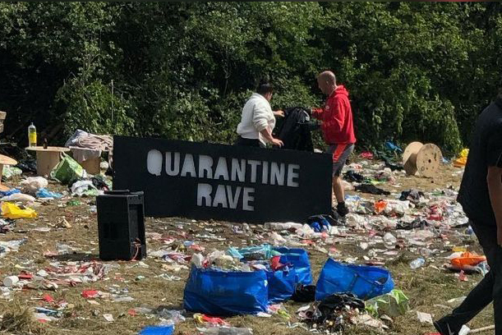
Police are asking local communities, particularly those in rural areas, to be alert to the signs of large and unlicensed gatherings following an incident near Dacorum recently.

With the recent warm weather and gradual easing of the Government’s lockdown measures, many people have let down their guard and flocked to beaches, parks and beauty spots to soak up the sun.

However social-distancing is still very much in place, meaning large gatherings still cannot happen while the country continues its efforts to prevent the spread of coronavirus.

Last month, officers in Dacorum turned away a vehicle at Pitstone Quarry, just over the border in Bedfordshire. The vehicle contained large speakers and its occupants admitted that they were planning to play music at a large gathering at the well-known beauty spot.

Chief Inspector Chris Treadwell, who leads Hertfordshire’s Crime Reduction and Community Safety Team, said: “Not only are unlicensed raves illegal but in the current circumstances, they clearly breach the Government measures stating there must be no large gatherings in order to help prevent the spread of COVID-19.

“These types of events are dangerous for attendees as there are often no crowd control measures, medical staff or security provision on site. Many people will likely accuse us of being spoilsports but we are here to keep the people of Hertfordshire safe.

“These unlicensed gatherings also pose difficulties for emergency services who, if in the event they are needed on the site, could struggle to access those who need help if no pre-planning has been undertaken by organisers.

“Therefore we would like to appeal for the public’s help and ask them to be alert to any suspicious activity in their communities. Often rave organisers choose rural locations so we are asking those living in these areas to remain vigilant, ensure their land is properly secured and report any suspicious activity to us. However, these events often also take place in industrial areas so we are asking everyone to keep an eye out.

“The key to stopping these events in their tracks is early intelligence so please let us know if you, or anyone else you know, has been approached looking for land to hire, even if the activity appears genuine.

“Those who organise these unlawful events will face the full force of the law in the form of arrest and prosecution. Those who choose to attend these events will also face enforcement action and could receive a criminal record. You could be risking your life by attending. Please, think twice.”

Please be aware of the signs to spot, and inform the police if you see the following:

• Cropped bolts on gates
• Flattened or disturbed hedgerows
• People in vehicles stopping to look into a field
• People climbing over a fence or gate to look into a field
• Posters or social media messages advertising a large gathering
• Vehicles entering fields or open spaces
• People unloading sound equipment

You can report information online, launch an online web chat or call the non-emergency number 101.

If you believe a crime is in action, or someone’s life is in danger, then please always dial 999.

Police appeal for witnesses after officer was racially abused

•Appeal after a Royston officer is subjected to racial abuse

•The incident occurred whilst the officer was on patrol

•Offender believed to be in the Heath car park at the time

Police in North Herts are currently investigating a report of racial abuse against one of the Royston Safer Neighbourhood officers, and are appealing for anyone with any information to come forward.

On Friday 26 June, at around 4.15pm, the officer was on patrol in a police vehicle near to the Heath. As he was driving slowly past the area, with his windows down, racial abuse was shouted at him from the car park area.

Neighbourhood Inspector James Lant said: “We take all allegations of racial abuse very seriously, as it is completely unacceptable, regardless of a person’s profession.

“We work very hard in Hertfordshire to encourage people to report race/hate crime and have specialist officers in post to facilitate this and offer specialist support. We offer our own staff the same service and I am keen to trace this individual or individuals, as soon as possible.

“If you were in the car park at this time and witnessed the abusive behaviour and have not yet spoken to the police, then please get in touch.”

Anyone with information is asked to contact the Sergeant Jon Vine via email at Jonathan.Vine@herts.pnn.police.uk

You can report information online at herts.police.uk/report, speak to an operator in our Force Communications Room via online web chat at herts.police.uk/contact or call our non-emergency number 101 quoting reference 41/50006/20.

If you wish to remain anonymous you can call Crimestoppers anonymously on 0800 555 111 or report information online at crimestoppers-uk.org.

The website hertsagainsthate.org has more information about hate crime and where they can be reported in Hertfordshire.

Secure your bicycle this summer

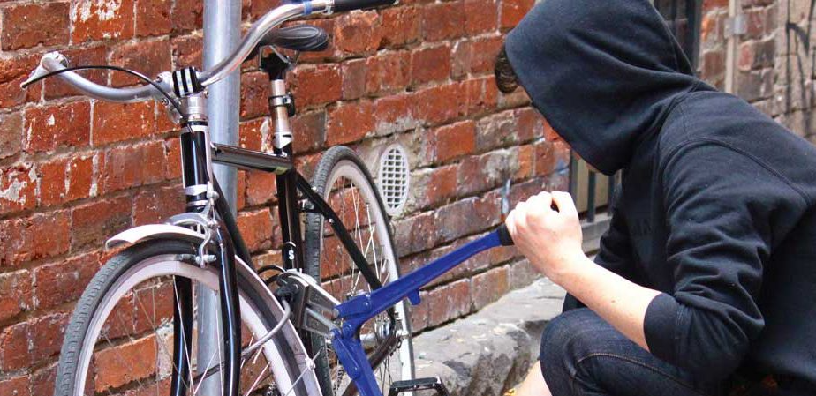

•Cyclists advised to register bikes on wwww.bikeregister.com

•As cycling increases during the summer so does bike theft

•Visit www.herts.police.uk/protectyourproperty for security tips

As the country emerges from lockdown and people are starting to get out and about more, Hertfordshire Constabulary is advising cyclists ensure their bicycles are secure at all times.

Summertime generally sees an increase in the number of people cycling and criminals are also on the lookout for easy targets, so the best way to keep your bike safe is to follow our security advice.

Crime Prevention Officer Colin Mann, from Hertfordshire Constabulary’s Crime Reduction Unit, said: “We started using a new bike marking system earlier this year, www.bikeregister.com. The system involves permanently and visibly marking a bike with a unique ID code which is applied to the bike frame on a tamper resistant QR label. This code proves ownership and places the details on Bike Register’s secure national database. Not only does the register deter thieves, it also alerts police that the bike is registered, so if it is stolen and then recovered, the code can be checked on the database to verify the true owner and we return it.”

The following advice will also help to keep your bike more secure:

•Invest in good quality security. Spend between 10-15per cent of the value of the bike on its security.

•Lock your bike frame AND wheels TO something with two different types of lock! Just using a chain and lock around a bike frame and wheels without locking it to something sturdy leaves your bike vulnerable to being taken. But locking only the frame or the wheels to something could result in unsecured parts being stolen.

•Use a chain and D-lock combination - avoid cable locks. Cable locks offer little deterrent to thieves as they are easy to cut with basic cable cutters, hacksaws and even wire-cutters. See our advice and recommendations below on locks.

•Lock your bike to something secure. Where possible secure your bike to a bike rack, pedestrian railings or some other large and tough object. Avoid locking to street signage – some are not very high, which makes it easy to lift bikes over the top of the post. Thieves may also un-bolt the sign to do this.

•Natural surveillance. Lock your bike where you can see it. If this is not possible, find a busy area.

•Security at home. Most bicycles are stolen from home so ensure your sheds, outbuildings and garages are secure. Consider installing ground anchors if you have a concrete floor. If not, look for security rated products specifically for wooden and metal sheds.

•Bike registration. Register your bike on The Bike Register, a free online property database which police use to check stolen property. That way, if your bike does get stolen, you have more chance of it being returned to you.

You can find further advice on securing bicycles and other valuables at www.herts.police.uk/protectyourproperty.

If you have any information about the bike thefts call the non-emergency number 101.

You can also report information online at herts.police.uk/report or speak to an operator in our Force Communications Room via our online web chat, which can be launched here: herts.police.uk/contact.

You can use our community voice platform ‘echo’ to let us know what you think we should be prioritising in your area. Your feedback will help towards shaping our local policing priorities, initiatives and campaigns. Visit bit.ly/herts-echo and tell us your thoughts.

Alternatively, you can stay 100% anonymous by contacting the independent charity Crimestoppers on 0800 555 111 or via their untraceable online form at crimestoppers-uk.org.

Local Crime Information

G4E - Ashwell, Hinxworth, Bygrave, Newnham and Caldecote

BURGLARY (NON DWELLING) - MANOR FARM, CHURCH LANE, BYGRAVE

Overnight from 1st to 2nd June offenders have approached the location in a vehicle across fields accessed via the A505 between BALDOCK and ROYSTON. More specifically underneath the railway bridge near to the BIOGEN plant.

Once they have arrived at the farm they have entered a barn by bending the outside metal skin of it and squeezing underneath. Once inside they have forced entry to a wooden shed like structure containing tools. They have entered this and removed tools from within.

They have drained approximately 3,000 litres of red diesel into an unknown vessel before hotwiring a 3 ton excavator and driving it out of the barn through the closed shutters. They have then loaded the excavator onto the vehicle they arrived in and have driven off back in the direction that they came in.
41/42828/20 refers

ATTEMPT BURGLARY - ASHWELL

Between material times 2 unknown offenders have tried to gain access to a barn. They have used a jemmy on the bottom of the door and snapped off the handle. They have been unsuccessful at gaining entry to the barn and have made off in a white vehicle towards Dunton.
41/43353/20 refers

THEFT – ASHWELL

Overnight on 4th to 5th June a vehicle had its number plates stolen from outside a property in Station Road, Ashwell.
41/43681/20 refers

G4D – Barley, Barkway, Reed, Therfield, Kelshall and
Nuthampstead

THEFT FROM MOTORVEHICLE – JACKSONS LANE- REED

Overnight on 7th of June, wing mirrors, wing mirror casings and four wheels were taken off of a vehicle that was parked on a drive.
41/44306/20 refers

THEFT – BALDOCK ROAD, ROYSTON

On the 13th June a set of golf clubs that were left at the side of a vehicle, whilst the owner was sorting out the boot of his car, were taken. A small white car was seen to pull up alongside the owners car, the offenders did not exit the vehicle, but reached out from the window and took the clubs. Vehicle then exited the car park in an unknown direction.
41/46127/20 refers

G3C - Sandon, Wallington, Rushden, Clothall and Weston

THEFT – HITCHIN ROAD, WESTON

On the 15th June between the hours of 0640 and 1710 a gate and coded lock were stolen from a property in Hitchin Road. Offenders removed the screws and hinges to take the gate, the property was not entered or any other items taken.
41/46702/20 refers

THEFT – LANNOCK HILL, WESTON

Between the hours of 1130am on 17th June and 1130 on 18th June, the post box was stolen from Lannock Hill.
41/47577/20 refers

Your local Neighbourhood Police Teams website

http://snt.herts.police.uk/Teams.aspx?TeamID=G01

Useful Links

http://www.herts.police.uk/

http://www.doglost.co.uk/

http://www.stolenhorseregister.com/

Royston Rural Neighbourhood Team Tel – 01438 757935

